Content for Green Together Experience

Templates for case studies showcasing Danish green partnerships, projects and solutions to be used in the digital Green Together Experience platform.

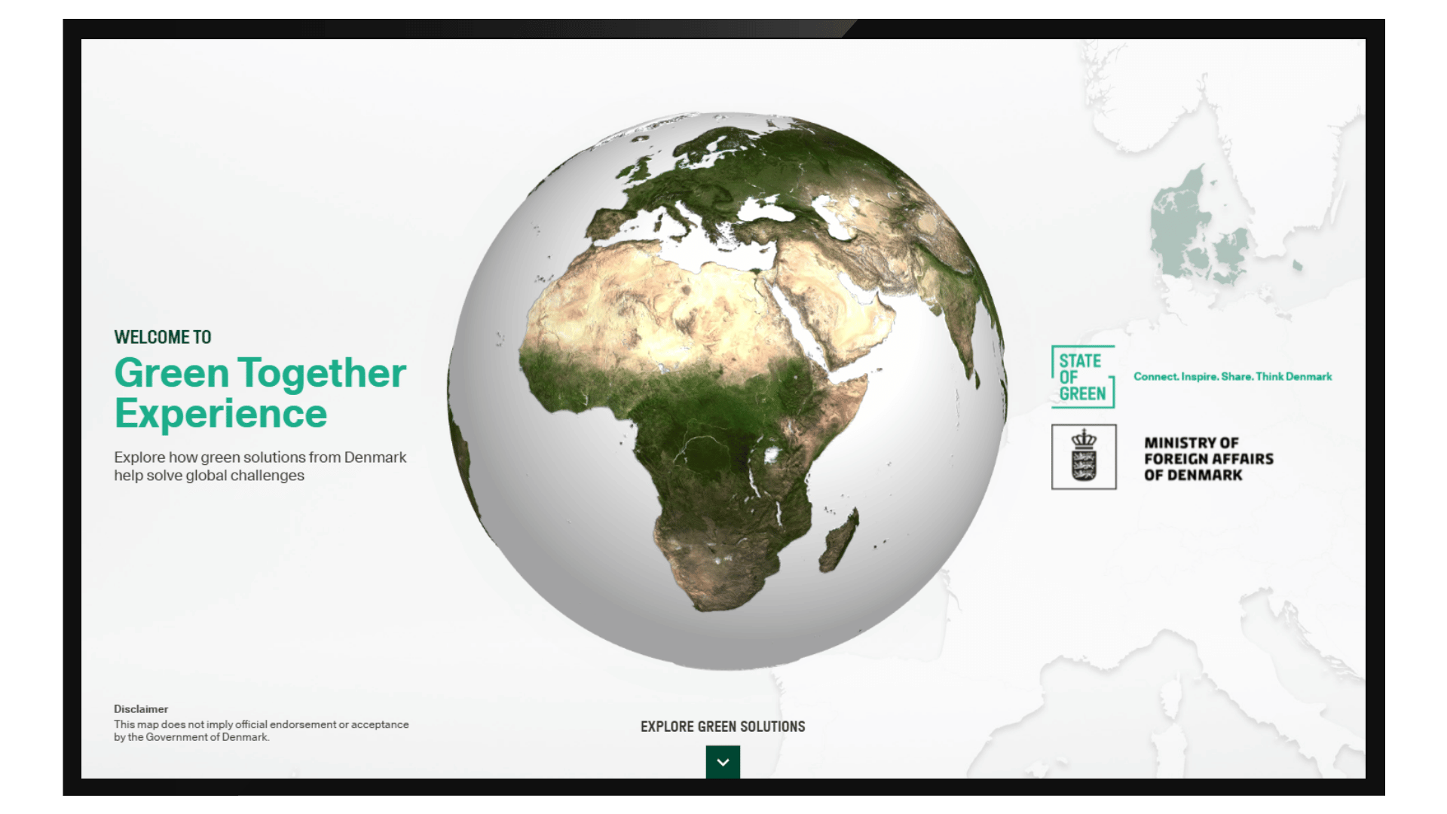

What is it?
Green Together Experience (GTE) is a digital and interactive platform developed in corporation between The Danish MFA and State of Green. The purpose of the platform is to showcase how Danish green solutions – private or public – are implemented in cooperation with local partners with a view to solve global challenges within green focus areas such as energy, water, and cities across the world.

The platform can be reached through the following URL: https://live.stateofgreen.com/green-together/#/challenges/

Who is it for?
GTE can be used by anyone working to promote Denmark and Danish green solutions internationally. This could be the Danish embassies, the Trade Council, Innovation Centres, Export Associations and Consulates.

How to use it?
GTE is a browser-based solution and can be used on touch screens, tablets or on your computer. GTE is a great dialogue tool to engage local stakeholders during events, expos, seminars, webinars or meetings, as well as a free opportunity to showcase Danish company solutions, government-to-government partnerships, or publicly funded activities and investments to an international audience.

Examples of previous use:
- COP29
- World Hydrogen Week 2024
- UIA World Congress of Architecture 2023
- IEA- and IWA-congress
- Delegation visits to House of Green
- PD/TC/EU events

Exhibition and promotional material for usage of Green Together Experience is accessible at the State of Green Toolbox - free to use in international events and conferences: https://stateofgreen.com/en/toolbox/?toolbox_events=197

Submitting content to Green Together Experience:
How to contribute with a local case
- Make sure the case fulfils the criteria for sustainability*
- Fill in the case template
- Make sure to collect relevant images and video materials related to the case
- Send the case template and images to State of Green at info@stateofgreen.com
- The case will be added to GTE and accessible online shortly after

*Criteria for submitting a case

*Company cases/solutions must comply with the following screening criteria to be included in GTE:

- Companies that identify themselves as a Danish company and have a Danish CVR number. If your
company is a Danish subsidiary to a foreign company, the Danish subsidiary must conduct activities that are not only related to sales and marketing in Denmark.
- The companies must comply with international standards of responsible business conduct. In general, the companies should comply with the United Nations Guiding Principles on Business and Human Rights or the UN Global Compact principles. Large companies should comply with the OECD Guidelines for Multinational Enterprises.
- The Danish case/solution must be implemented internationally to be added to the platform – not only in Denmark
- The company must offer exportable services or solutions which contribute to green energy production, energy-, water- or resource efficiency in production or operations, and/or contribute to at least one of the six environmental objectives in the EU taxonomy.
- Companies that solely produce sustainable products to the B2C market do not qualify, as the platform does not target private consumers (B2C).

*Cases on public funding, climate aid and G2G partnerships must comply with the following screening criteria to be included in GTE:

- Development finance activities must evolve around green energy production, energy-, water- or resource efficiency, and/or at least one of the six environmental objectives in the EU taxonomy.
- All Danish development finance activities that are defined as climate (adaptation and mitigation), biodiversity or general environment relevant according to the OECD DAC statistical criteria and the Rio Makers.
- TC-cases must comply with the criteria for company cases as stated above.

Need help with your case contribution?

Contact person - State of Green:
Joel Jonsson - jjo@stateofgreen.com - +45 40106518

Contact person – MFA Public Diplomacy:
Rikke Zeuner - RIKZEU@UM.DK - +45 61979064

Case template
See visual examples below the template.

Case headline (make it catchy)

Make it catchy and as straight to the point as possible.

Sector

Which sector/subsector does the case belong to – e.g. offshore wind energy, waste to energy, non-revenue water, legislation etc.
Introductory paragraph

A short description of the most important points from the case / A quick overview of the contents of the case:

Around 100 characters

Country and city

Where is the solution implemented?
Country and city (where the hotspot will be placed).

Challenge(s)

What challenge does the case address – e.g. air pollution, lack of climate resilience, water loss, large energy consumption, lack unstable energy security etc.

(Min 450 characters)

Solution(s)

Description of the solution itself – e.g. a pump, a partnership, a machine / product – in use. Please describe its application.
The case should be a named case (not a product description), meaning that it must describe a concrete, (soon-to-be) implemented solution.
(Min 450 characters)

Result(s)

What results have you seen – e.g. reduced water loss, increased energy efficiency, environmental gains? Support with numbers such as payback time for the investment, energy savings, water savings, etc.
How and who was there created value for?

(Min 450 characters)
Featured image

A featured image that can be used as a header image for the case story. Preferably in high resolution. Can also be attached in email.

Video

If there is a video related to the case, please insert URL to either Vimeo or YouTube.
Danish Company/Organisation/Contributor  Fill out the bullets to the right. | Fact box:  Name:  Specialization:  Founded:  Size:  HQ:  Link:  Insert short description about the Danish company/organisation/contributor below (max 100 words):
Logo from company/organisation partner

Preferably in high resolution and transparent (PNG). Can also be attached in email.
Local Partner/Organisation/contributor  Fill out the bullets to the right. | Fact box:  Name:  Specialization:  Founded:  Size:  HQ:  Insert short description about the Danish company/organisation/contributor below (max 100 words):
Logo from local partner

Preferably in high resolution and transparent (PNG). Can also be attached in email.

Link to further reader

Visual example on Green Together Experience:
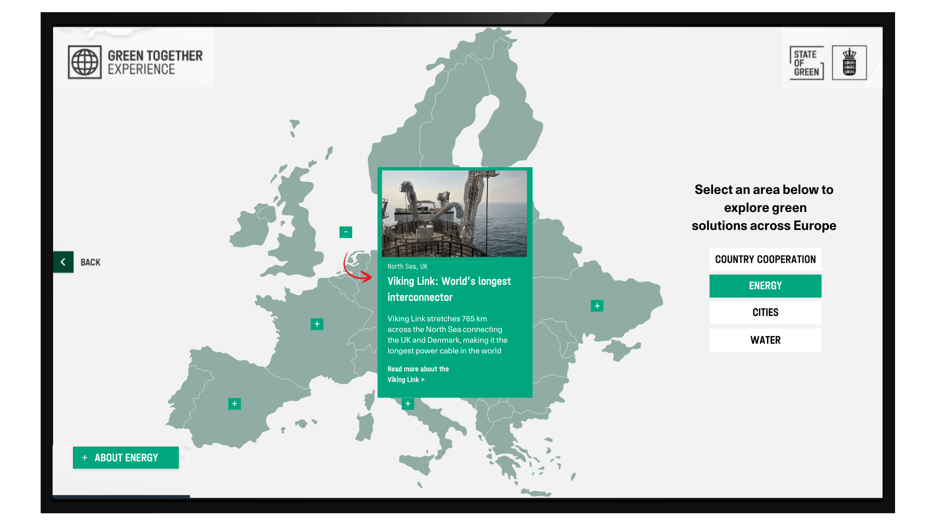
The following image is a mockup. The final result may vary.

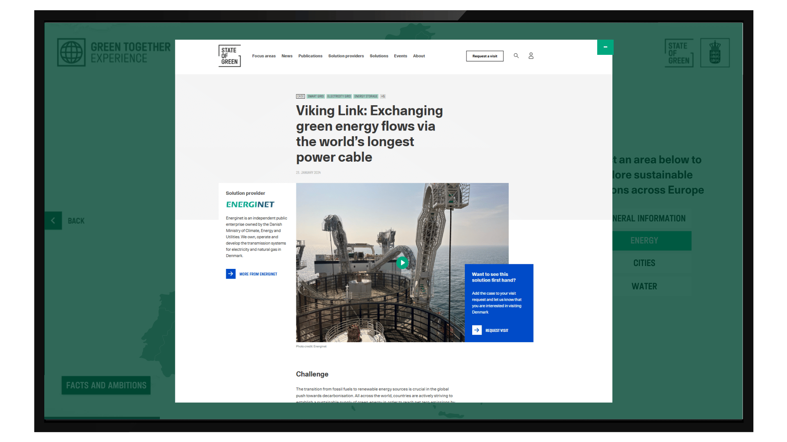
The following image is a mockup. The final result may vary.

Find inspiration from other cases at stateofgreen.com/solutions

See examples of previous cases at Green Together Experience:
- Nature-based solution: https://live.stateofgreen.com/green-together/#/challenges/2305/2414/
- Non-revenue water: https://live.stateofgreen.com/green-together/#/challenges/2305/2412/
- Waste reduction: https://live.stateofgreen.com/green-together/#/challenges/2306/2415/

- Counteracting climate change, 2 - Climate change adaptation/mitigation, 3 - Sustainable use and protection of water- and ocean resources, 4 - Transition to circular economy, 5 - Prevention and combating of pollution, 6 - Protection and Restoration of Biodiversity and Ecosystems.
- Counteracting climate change, 2 - Climate change adaptation/mitigation, 3 - Sustainable use and protection of water- and ocean resources, 4 - Transition to circular economy, 5 - Prevention and combating of pollution, 6 - Protection and Restoration of Biodiversity and Ecosystems.

